Nest an object in another object in order to have binding work for a list of objects.

I want several images in a gridcell. Binding should be something like:

<ItemsControl ItemsSource="{Binding MyImageFolderList}" DisplayMemberPath="MyImagePath"/>

So make an object called MyImageFolder with a property MyImages which is a list of MyImage objects. MyImage has a property MyImagePath, which is the actual string path. MyImageFolderList is a list of MyImageFolder as a property of pSHARE.

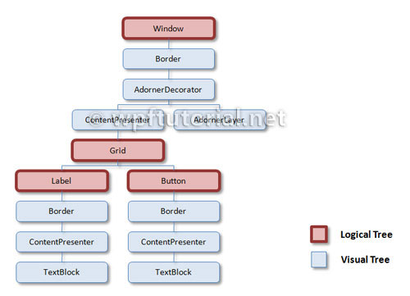

The DataContext of the CSVControl (window) is the pSHARE object. The CSVControl has a Grid that has autogenerated columns with textboxes. That is the [logical tree](http://www.wpftutorial.net/logicalandvisualtree.html). The logical tree is responsible for binding. However we add two columns through a DataGrid.CellTemplate. Since the ItemsControl is outside the logical tree, you have to explicitly point to the source for the binding. You can do that several [ways](https://msdn.microsoft.com/en-us/library/vstudio/ms746695(v=vs.100).aspx).

If we use:

<ItemsControl ItemsSource="{Binding DataContext.MyImageFolderList, RelativeSource = {RelativeSource FindAncestor, AncestorType={x:Type DataGrid}}}"/>

We get: pCOLADnamespace.MyImageFolder 7 times in every cell. But we need the property MyImages of those folders. If we use:

<ItemsControl ItemsSource="{Binding DataContext.MyImageFolderList,Converter={StaticResource myTestConverter},

RelativeSource={RelativeSource FindAncestor, AncestorType={x:Type DataGrid}}}"

DisplayMemberPath="MyImages[0]"/>

We get 7 times pCOLADnamespace.MyImage in every cell. With MyImages we get (Collection) 7 times.

DisplayMemberPath="MyImage.MyImagePath"

Maybe find answer [here](http://www.codeproject.com/Articles/991990/A-n-level-Nested-Directory-Tree-WPF-Demo).

Finally asked [Question](Question%20about%20images%20in%20grid.docx) on Stackoverflow.com.